Lin alg discuss

Cheng Chang INSTRUCTOR MANAGER
Discussion #1
COLLAPSE
窗体顶端
For this week's discussion, we look at the Gauss-Jordan method, for example, suppose a linear system has the following reduced augmented matrix
Is the system consistent or inconsistent? In general, given a reduced echelon matrix, how do we know if the system is consistent or inconsistent?
The deadline for this discussion topic is Tuesday (9/18).
窗体底端
2 months ago
Jeremy Schreiber
RE: Discussion #1
COLLAPSE
窗体顶端
The system is inconsistent.
The reason is that the last row implies that 0 = 1, which is impossible.
In general, an inconsistent system of linear equations in reduced row echelon form will have at least one row of the form 0 = x (x not equal to 0).

Reply to Jeremy Schreiber Quote Email Author
窗体底端
Hide 1 reply

2 months ago
Cheng Chang INSTRUCTOR MANAGER
RE: Discussion #1
COLLAPSE
窗体顶端
Very good explanation.
Reply to Cheng Chang Quote Email Author
窗体底端

2 months ago
Evan Kim
RE: Discussion #1
COLLAPSE
窗体顶端
Jeremy is correct.
Also it appears that this system has 4 variables and only 3 equations, which makes it an underdetermined system and will contain either no solutions or an infinite amount. Given a linear system based on the reduced row echelon matrix, we know it is inconsistent because the augmented matrix contains a row of 0000s, which implies implies x1 + x2 + x3 + x4 = 0

Reply to Evan Kim Quote Email Author
窗体底端
Hide 1 reply

2 months ago
Cheng Chang INSTRUCTOR MANAGER
RE: Discussion #1
COLLAPSE
窗体顶端
Excellent Evan! This is as good as the one provided by Jeremy, but from a different perspective.
Reply to Cheng Chang Quote Email Author
窗体底端

2 months ago
Armani Willis
RE: Discussion #1
COLLAPSE
窗体顶端
c: 0=1
c is false.
Reply to Armani Willis Quote
窗体底端
Hide 1 reply

2 months ago
Armani Willis
RE: Discussion #1
COLLAPSE
窗体顶端
f is an inconsistent system
Reply to Armani Willis Quote
窗体底端
Select: All None
- Message Actions

- Expand All

- Collapse All
Week 2

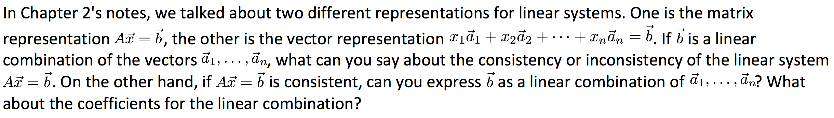

Jeremy Schreiber
RE: Discussion #2
COLLAPSE
窗体顶端
If the vector b can be represented as a linear combination of vectors a1, a2, etc, then the matrix representation must be consistent (have at least one solution). Similarly, if the matrix form of the system is consistent it can be represented by a linear combination. This is because the different representations are just two ways of visualizing the SAME system of linear equations. A system cannot be consistent and inconsistent depending on the way it's written down.
The coefficients of the linear combinations will be either real numbers (for a single solution) or parameterized values (for infinite solutions).
Reply to Jeremy Schreiber Quote Email Author
窗体底端
Hide 1 reply

2 months ago
Cheng Chang INSTRUCTOR MANAGER
RE: Discussion #2
COLLAPSE
窗体顶端
Excellent answer!
Reply to Cheng Chang Quote Email Author
窗体底端

2 months ago
Sarah Mitchell
RE: Discussion #2
COLLAPSE
窗体顶端
Please see attached.
Thank you,
Sarah M
Discussion #2.pdf (413.721 KB)
Reply to Sarah Mitchell Quote Email Author
窗体底端
Hide 1 reply

2 months ago
Cheng Chang INSTRUCTOR MANAGER
RE: Discussion #2
COLLAPSE
窗体顶端
Okay, you can certainly use the determinant to answer this question, but the determinant determines whether or not the linear system has a unique solution. Instead, if a linear system is consistent, it's very possible that there are infinitely many solutions.
Reply to Cheng Chang Quote Email Author
窗体底端

2 months ago
Paul Mickus
RE: Discussion #2
COLLAPSE
窗体顶端
From Definition 1.5 in the Chapter 2 notes. If vector b is linear combination of the vectors a1...an then the linear system Ax=b is consistent. Furthermore if Ax=b is consistent then vector b is a linear combination of vectors a1..an. The coefficients are the solution to the linear system.
Reply to Paul Mickus Quote Email Author
窗体底端
Hide 1 reply

2 months ago
Cheng Chang INSTRUCTOR MANAGER
RE: Discussion #2
COLLAPSE
窗体顶端
Correct answer.
Reply to Cheng Chang Quote Email Author
窗体底端

1 month ago
Armani Willis
RE: Discussion #2
COLLAPSE
窗体顶端
if b=Ax is consistent, then any x may be zero, and any value in set a may be zero,
but at least 1 x may not be zero, and all values in any a must map to 1 value in the row of b if b is not zero.
else, this graph is inconsistent.
Ex. A= 1 0 0 5
0 1 0 9
0 0 1 4
is inconsistent if for c, c3=0, or for b, 9 was instead 0.
窗体底端
Cheng Chang INSTRUCTOR MANAGER
Discussion #3
COLLAPSE
窗体顶端
In Chapter 1, we learned that for any linear system, there are three possibilities
- No solution
- One unique solution
- Infinitely many solutions
Use the knowledge we have so far to briefly explain why this is true? Or give conditions under which each possibility is true.

Reply to Cheng Chang Quote Email Author
窗体底端

2 months ago
Evan Kim
RE: Discussion #3
COLLAPSE
窗体顶端

This is how I try to intuitively think about and visualize how each linear system interacts when there are no solutions, one solution, and infinite solutions
When a linear system has no solution, it means that there are no points from the plane of the equation that intersect with any of the other equations because they are parallel in space so will never collide.
When a linear system has one solution, there is a single point that each plane in the equation will intersect with. The linear system will only have an infinite number of solutions if the planes are the exact same line.
Reply to Evan Kim Quote Email Author
窗体底端

2 months ago
Jeremy Schreiber
RE: Discussion #3
COLLAPSE
窗体顶端
A "solution" to a linear system is simply a set of points in n-variables that simultaneously satisfy each equation in the system. That is, the solution is the intersection of the solution sets for each equation (the points in space that each equation have in common). From that perspective, it makes sense that there must be only three possibilities. Either:
a. The equations share no points in common: In this case the sets of points that satisfy each equation are disjoint (their intersection is the empty set) and hence there is no solution
b. The equations share exactly one point: In this case the systems overlap at a single point in space and that single point represents the unique solution. In other words, the intersection of the sets of points that satisfy each equation contains only one element.
c. The equations share infinitely many points: Since we're dealing with LINEAR equations there is no way for them to intersect at a finite number of more than one discrete point. If a system is consistent and has more than one solution, it will have infinitely many solutions.

Reply to Jeremy Schreiber Quote Email Author
窗体底端

2 months ago
Sarah Mitchell
RE: Discussion #3
COLLAPSE
窗体顶端
1. No solution (inconsistent system) means that the lines and/or points never intersect. For example, parallel lines have no solution.
2. One unique solution (consistent system) mean the system has one exact solution or the lines intersect.
3. Infinitely many solutions (consistent system) means that any value would make the system or equation true. For example x+y=3 & 2x+2y=6 has infinitely many solutions.
Reply to Sarah Mitchell Quote Email Author
窗体底端

1 month ago
Paul Mickus
RE: Discussion #3
COLLAPSE
窗体顶端
As above have noted there is a geometric interpretation for each of these possibilities. More specifically in 3d space with 3 planes defined by 3 equations, a no solution means then the 3 planes defined by the set of equations have no common point or intersection. A unique solution is the intersection of these planes at one common point. Infinitely many solutions is where the the planes intersect at a common line, the 2 planes are the same and intersect at a line with the third plane, or all 3 planes are the same.
It is interesting to note that infinitely many solutions can be achieved by different arrangements of geometrical objects depending on the dimension of space given.

Reply to Paul Mickus Quote Email Author
窗体底端

1 month ago
Cheng Chang INSTRUCTOR MANAGER
RE: Discussion #3
COLLAPSE
窗体顶端
Reply to Cheng Chang Quote Email Author
窗体底端

1 month ago
Armani Willis
RE: Discussion #3
COLLAPSE
窗体顶端
For a linear system:
No solution means that the graph is not reducible or not consistent. this graph has no identity.
1 0 0 9
0 1 -1 3
0 0 0 0
1 unique solution means that it is not reducible but is consistent, it has no identity.
1 0 0 9
0 2 0 3
0 0 1 1
inf solutions means that this graph has an identity, thus is scalable by C, or any real #.
1 0 0 9
0 1 0 3
0 0 1 1
can b scaled by any C.
窗体底端
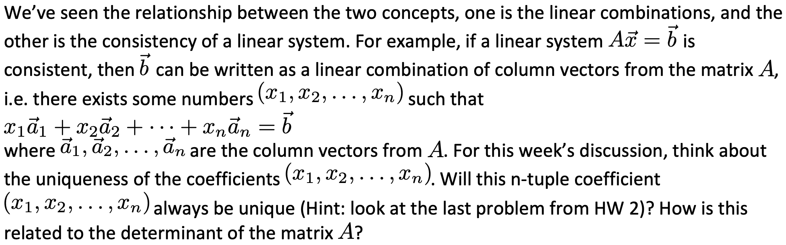

Jeremy Schreiber
RE: Discussion #4
COLLAPSE
窗体顶端
The n-tuple coefficient (x1, x2, ..., xn) for a system of linear equations that can be expressed as a linear combination is not guaranteed to be unique. As the last example of HW 2 illustrates, the system may have infinite solutions. The determinant of the coefficient matrix of the system however, can be used to determine if the system has a unique solution. If the determinant of such a coefficient matrix is not equal to zero, then the system has a unique solution, otherwise the system can have either no solution or infinite solutions.
This is best illustrated with an example. Consider the following system of linear equations in two-variables:
ax1 + by1 = k1 (1)
cx2 + dy2 = k2 (2)
This produces a coefficient matrix of (forgive the lack of brackets)
a b
c d
The determinant of this matrix is:,
det = ad - bc
If the determinant is zero, then we can write:
ad = bc
Dividing both sides by the quantity bd, produces the following:
a/b = c/d
Notice that a/b is the slope of the line represented by (1) and c/d is the slope of the line represented by (2). This means that when the determinant is zero, the slopes of the two lines are equal. In this case either the two lines are the same (infinite solutions) or the two lines are parallel (no solution). Only when the determinant is NOT zero will the slopes of the two lines be different, which will produce a unique solution.

Reply to Jeremy Schreiber Quote Email Author
窗体底端
Hide 1 reply

1 month ago
Cheng Chang INSTRUCTOR MANAGER
RE: Discussion #4
COLLAPSE

1 month ago
Evan Kim
RE: Discussion #4
COLLAPSE
窗体顶端
The n-tuple coefficient will not always be unique. Sometimes it can also have zero solutions and be inconsistent if you have a row of 0's when doing Gaussian elimination. Other times it can have an infinite number of solutions as well.
If the determinant is zero, than the system could have either zero or infinite number of solutions, but if the determinant is not zero than the solution will be unique.
Reply to Evan Kim Quote Email Author
窗体底端

1 month ago
Sarah Mitchell
RE: Discussion #4
COLLAPSE
窗体顶端
the n-tuple coefficient ( x1, x2, . . . , xn ) will not always be unique; although mostly you would have an unique solution you may also have infinite solutions or even no solution.
If the determinate of matrix A equals zero then you will have zero solutions or infinitely many solutions. However, when the derterminate of matrix A is not zero you will have an unique solution.
Reply to Sarah Mitchell Quote Email Author
窗体底端

1 month ago
Paul Mickus
RE: Discussion #4
COLLAPSE
窗体顶端
The n-tuple does not necessarily have to be unique. As a consistent linear system has either one solution of infinitely many solutions. However if the determinant of A is non-zero then the solution is unique.

Reply to Paul Mickus Quote Email Author
窗体底端

1 month ago
Evan Kim
RE: Discussion #4
COLLAPSE
窗体顶端
How does the relationship between linear combinations and linear system consistency apply to vector spaces?

Is it that linear combinations within a consistent linear system will be consistently or not consistently a vector space?
Reply to Evan Kim Quote Email Author
窗体底端

1 month ago
Armani Willis
RE: Discussion #4
COLLAPSE
窗体顶端
the coefficients will always be unique if the matrix has only 1 unique solution, and
if the system has inf solutions, then there is only 1 scalar that works for all of them.
otherwise, if there is only 1 linear combination that works for b, then this combination
is the unique combo for A.
窗体底端
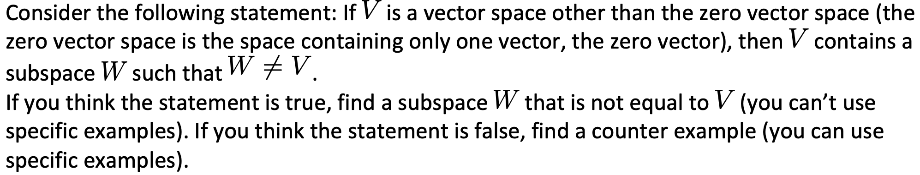

Evan Kim
RE: Discussion #5
COLLAPSE
窗体顶端
False. A subspace can be the entirety of a vector space. A set of vectors can span the entire R^3 space.

Example 5 on page 177:
Let u = (u1, u2, u3) be any vector in R^3. Find scalars c1, c2, and c3 such that (u1, u2, u3) = c1(1,2,3,) + c2(0,1,2) + c3(-2,-,1)
This coefficient matrix has a nonzero determinant of -1 so the system has a unique solution, that solution being (u1, u2, u3) which is equal to any vector within the R^3 space.
Reply to Evan Kim Quote Email Author
窗体底端

1 month ago
Jeremy Schreiber
RE: Discussion #5
COLLAPSE
窗体顶端
I believe the statement is true.
Let's try a proof by contradiction: Assume that the statement is false. That is, assume that the all subspaces,W, of V are in fact equal to V. Let V be a vector space in n dimensions with elements (v1, v2,...vn) and let W be a subset of V such that the value of the nth dimension is 0, with elements (w1, w2, ..., w(n-1), 0). Its clear from this definition that each element in W is an element in V, however it is NOT the case that every element in V is an element in W, since any element that has a non-zero value in its nth dimension will not be in W. Therefore W is not equal to V, which is a contradiction of our original assumption. Therefore the assumption must be false, and thus the statement is true.
Reply to Jeremy Schreiber Quote Email Author
窗体底端
Hide 1 reply

1 month ago
Cheng Chang INSTRUCTOR MANAGER
RE: Discussion #5
COLLAPSE
窗体顶端
Good, this is correct.
Reply to Cheng Chang Quote Email Author
窗体底端

1 month ago
Sarah Mitchell
RE: Discussion #5
COLLAPSE
窗体顶端
I am not 100% sure I am grasping this correctly but, I think the statement is true. On page 178 Theorem 4.7 states:
If S = { v1, v2,...,vk} is a set of vectors in a vector space V, then span (S) is a subspace of V. Moreover, span(S) is the smallest subspace of V that contains S, in the sense that every other subspace of V that contains S must contain span(S).

For example:
u = c1v1 + . . . + ckvk
v = d1v1 + . . . + dkvk
Where c1,c2, . . . , ck and d1,d2, . . . , dk are scalars. Then u + v = (c1 + d1)v1 + . . . + (ck + dk)vk
and cu = (cc1)v1 + . . . + (cck)vk
Therefore, span(S) is a subspace of V. and is the smallest subspace of V that contains S.
Reply to Sarah Mitchell Quote Email Author
窗体底端

1 month ago
Paul Mickus
RE: Discussion #5
COLLAPSE
窗体顶端
True
There exists 2 trivial subspaces the zero vector space and the space itself or V = W. All other subspaces are called proper subspaces where V != W. One example is line through the origin of R^2 . All vectors on this line satisfy the closure axioms and contain the zero vector.

Reply to Paul Mickus Quote Email Author
窗体底端

1 month ago
Armani Willis
RE: Discussion #5
COLLAPSE
窗体顶端
If i put a square fence around a field,
and this field has a tree S inside of it,
then i can put another square fence
within field A that surrounds tree S.
thus S is not intrinsically different from A
since S is still inside of A.
systems affected by S still maintain the
condition that there are some variables that are
either 0 or not 0 unlike variable coefficients in S.
Reply to Armani Willis Quote
窗体底端

1 month ago
Armani Willis
RE: Discussion #5
COLLAPSE
窗体顶端
W cant be V unless V was subspace W.
窗体底端
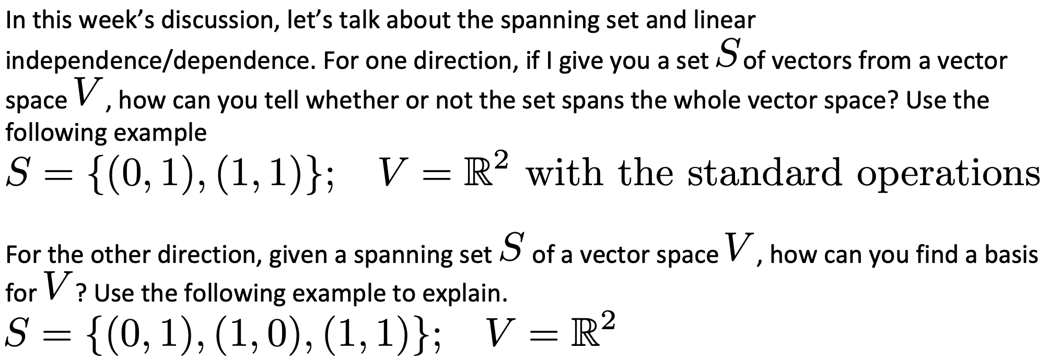

Evan Kim
RE: Discussion #7
COLLAPSE
窗体顶端
For a set S to span the entire vector space, each vector would have to be a linear combination within the vector space.
Set S = a vector U, which represents any linear combination of vectors:
(u1, u2) = c1(0,1) + c2(1,1)
c1 and c2 are scalars of real numbers. If there is a nonzero determinant on the right side, then there is a unique combination, vector U and we know the set spans the whole vector space.
To find a basis of S = {(0,1), (1,0)}, we have to verify that S spans the vector space and S is linearly independent. To find if S spans the vector space, verify that every vector in V can be written as a linear combination of vectors of S. The second criteria is that we have to find out whether S is linearly independent. If a system of equations is linearly independent, then then there are no other non-trivial solutions when c1x1 + c2x2 = 0. You can find this out by setting the system of equations = to 0 and reducing the augmented matrix down to RREF. If c1 and c2 = 0, then the system is linearly independent.
The standard basis for R^2 is S = {(0,1), (1,0))} and so n = 2 (number of vectors in set). Since S = {(0,1), (1,0), (1,1)}, n = 3 and this means that S is linearly dependent and therefore cannot be a basis for R^2

Reply to Evan Kim Quote Email Author
Hello, the event preceeding this one was checked
for its validity and returned an inconsistent subspace that had no basis.
I would like the augmentation vector for the argument:
negative one squared is a waste of everybody's time,
and a consistent basis for this arrgument, and its augmentation.
That is all.
窗体底端
Hide 1 reply

23 days ago
Cheng Chang INSTRUCTOR MANAGER
RE: Discussion #7
COLLAPSE
窗体顶端
Very good, correct answer.
Reply to Cheng Chang Quote Email Author
窗体底端

26 days ago
Jeremy Schreiber
RE: Discussion #7
COLLAPSE
窗体顶端
It's possible to determine if a set of vectors, S, spans a vector space, V, by demonstrating that the equation Ax = b, where A is the matrix constructed using the vectors of S as its columns and x is the vector of unknowns, has a solution for all vectors, b, in V. There are two ways to do this: one way that will always work is to adjoin A with a generic b (using variables in place of numbers for b's elements) and use gaussian elimination to determine if a solution is possible. Another way that only applies if A is a square matrix, is to recognize that a solution to Ax = b is guaranteed if A is non-singular. The determinant can be used to deduce invertibility assuming the maxtrix is a reasonable size (a non-zero determinant indicates the matrix is invertible), otherwise the inverse matrix may have to be calculated manually or using a calculator/computer. In the example provided by the question, A would be:
0 1
1 1
which has a determinant of (0*1 - 1*1) = -1. Since -1 is not zero is non-singular and thus a unique solution exists for all vectors, b, in V. Therefore S spans V.

Finding the basis for a vector space, V, given a spanning set, S, can be easily accomplished by creating a matrix with the vectors in S as its columns and using elimination to locate dependant columns (columns that can be created via linear combinations of other columns in S). If you eliminate the dependant columns, the remaining columns will still span V and will be linearly independent. Thus the remaining columns will provide a basis for V. In the example given by the question, no matrix need be created because it's obvious that the vector (1,1) is simply the sum of the other two vectors. Thus (1,1) can be eliminated from S, leaving (0,1) and (1,0). Since the remaining vectors are guaranteed to span S (as the original 3 did) and they're linearly independant, they represent a Basis for R2.

Reply to Jeremy Schreiber Quote Email Author
窗体底端
Hide 2 replies

25 days ago
Evan Kim
RE: Discussion #7
COLLAPSE
窗体顶端
Very well put! I like how straightforward your response was. It was easy to see where my line of thinking was off in my post.
Reply to Evan Kim Quote Email Author
窗体底端

23 days ago
Cheng Chang INSTRUCTOR MANAGER
RE: Discussion #7
COLLAPSE
窗体顶端
Excellent writing as always! I'm very impressed!
Reply to Cheng Chang Quote Email Author
窗体底端

25 days ago
Sarah Mitchell
RE: Discussion #7
COLLAPSE
窗体顶端
Please see attached

Thank you,
Sarah M
Discussion #7.pdf (633.967 KB)
Reply to Sarah Mitchell Quote Email Author
窗体底端

23 days ago
Armani Willis
RE: Discussion #7
COLLAPSE
窗体顶端
Running the calculation:
0 1 1 1 0 0 0 1 0 1 0 0 Neither of these are consistent systems,
1 1 1 0 1 1, 1 1 0 0 1 0, neither of these can span any space.
We can solve the second problem by completing the square:
0 1 0 1 1 0 0 0 0 1 0 0 1 0 0 0 Since there must be 1x and 1y for the third map, but only
1 0 0 1 0 1 0 0 1 0 0 0 0 1 0 0 1x and 1y for the other 2, there is no combo of one that will result in the other.
1 1 0 1 0 0 0 1,1 1 0 0 0 0 0 0, these systems are also non consistent, and cannot span r2.

Reply to Armani Willis Quote
窗体底端

23 days ago
Armani Willis
RE: Discussion #7
COLLAPSE
窗体顶端
Dr. Chang,
We are going over alot of logic for understanding systems,
I was wondering, since it is a logical progression,
how to raise a single base by a system power,
like c^A, x^A, A^y, or M^A, where y is an undefined variable.
I have been searching all over the internet, there are no
graph programs for doing that.
Reply to Armani Willis Quote
窗体底端
Hide 1 reply

23 days ago
Cheng Chang INSTRUCTOR MANAGER
RE: Discussion #7
COLLAPSE
窗体顶端
Why do you have so many powers? When you raise a power to another power, the number becomes really large.
窗体底端
could you please demonstrate it for us because i dont understand.
like for instance
(x+y+z﻿)^(a+b+c) would mean that the final result would depend on what the matrix was actually for.﻿﻿﻿﻿﻿﻿
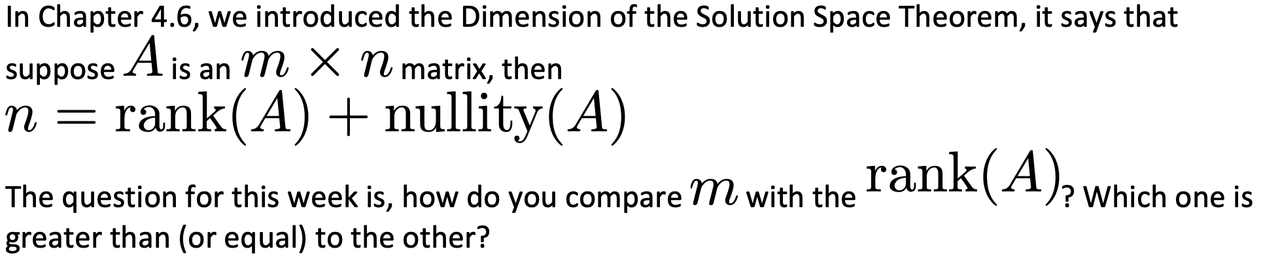

20 days ago
Jeremy Schreiber
RE: Discussion #8
COLLAPSE
窗体顶端
For an m x n matrix, A, rank(A) will always be less-than-or-equal-to m (rank(A) <= m). This is because rank(A) is equal to to the number of pivots (leading 1s) in the reduced row-echelon form of A. This number cannot be greater than m by definition, but it could be less than m if rref(A) has one or more rows of all zeros. Thus rank(A) <= m.
Reply to Jeremy Schreiber Quote Email Author
窗体底端
Hide 1 reply

17 days ago
Cheng Chang INSTRUCTOR MANAGER
RE: Discussion #8
COLLAPSE
窗体顶端
Good answer and correct.
Reply to Cheng Chang Quote Email Author
窗体底端

19 days ago
Sarah Mitchell
RE: Discussion #8
COLLAPSE
窗体顶端
The definition of the Rank of a Matrix states that the dimension of the row (or column) space of a matrix A is the Rank of A and is denoted by rank (A).
If A is an n x n matrix, then Rank(A) = n.
Therefore, if in a m x n matrix rank(A) may be less than or equal to m but never greater.
Reply to Sarah Mitchell Quote Email Author
窗体底端
Hide 1 reply

17 days ago
Cheng Chang INSTRUCTOR MANAGER
RE: Discussion #8
COLLAPSE
窗体顶端
The rank of an n x n matrix is not necessarily n.
Reply to Cheng Chang Quote Email Author
窗体底端

19 days ago
Evan Kim
RE: Discussion #8
COLLAPSE
窗体顶端
Rank(A) consists of all the row spaces within a matrix A m x n so Rank(A) = m rows in matrix A. Rank(A) can be less then M rows when there exists a nullspace (all zero rows) within the matrix, denoted above as nullity(A).
Reply to Evan Kim Quote Email Author
窗体底端
Hide 1 reply

17 days ago
Cheng Chang INSTRUCTOR MANAGER
RE: Discussion #8
COLLAPSE
窗体顶端
Very good!
Reply to Cheng Chang Quote Email Author
窗体底端

18 days ago
Paul Mickus
RE: Discussion #8
COLLAPSE
窗体顶端
The dimension of row space and dimension of column space are equivalent. If m > n then maximum Rank is n. Rank will always be less than or equal to m.
Reply to Paul Mickus Quote Email Author
窗体底端
Hide 1 reply

17 days ago
Cheng Chang INSTRUCTOR MANAGER
RE: Discussion #8
COLLAPSE
窗体顶端
Correct.
Reply to Cheng Chang Quote Email Author
窗体底端

1 hour ago
Armani Willis
RE: Discussion #8
COLLAPSE
窗体顶端
if n=rank(A)+null(A), then
m=rank(B)+null(B) also/
If phrase is true, then rank(B) cannot be less than n even if n>m.
Reply to Armani Willis Quote
窗体底端
Hide 1 reply

1 hour ago
Armani Willis
RE: Discussion #8
COLLAPSE
窗体顶端
Professor, isnt there a pemdas of systems?
(A+B)-C, A^B, A*B, A/B,A+B,A-B.
we never learned A^B,
what is the logic of exponential systems?
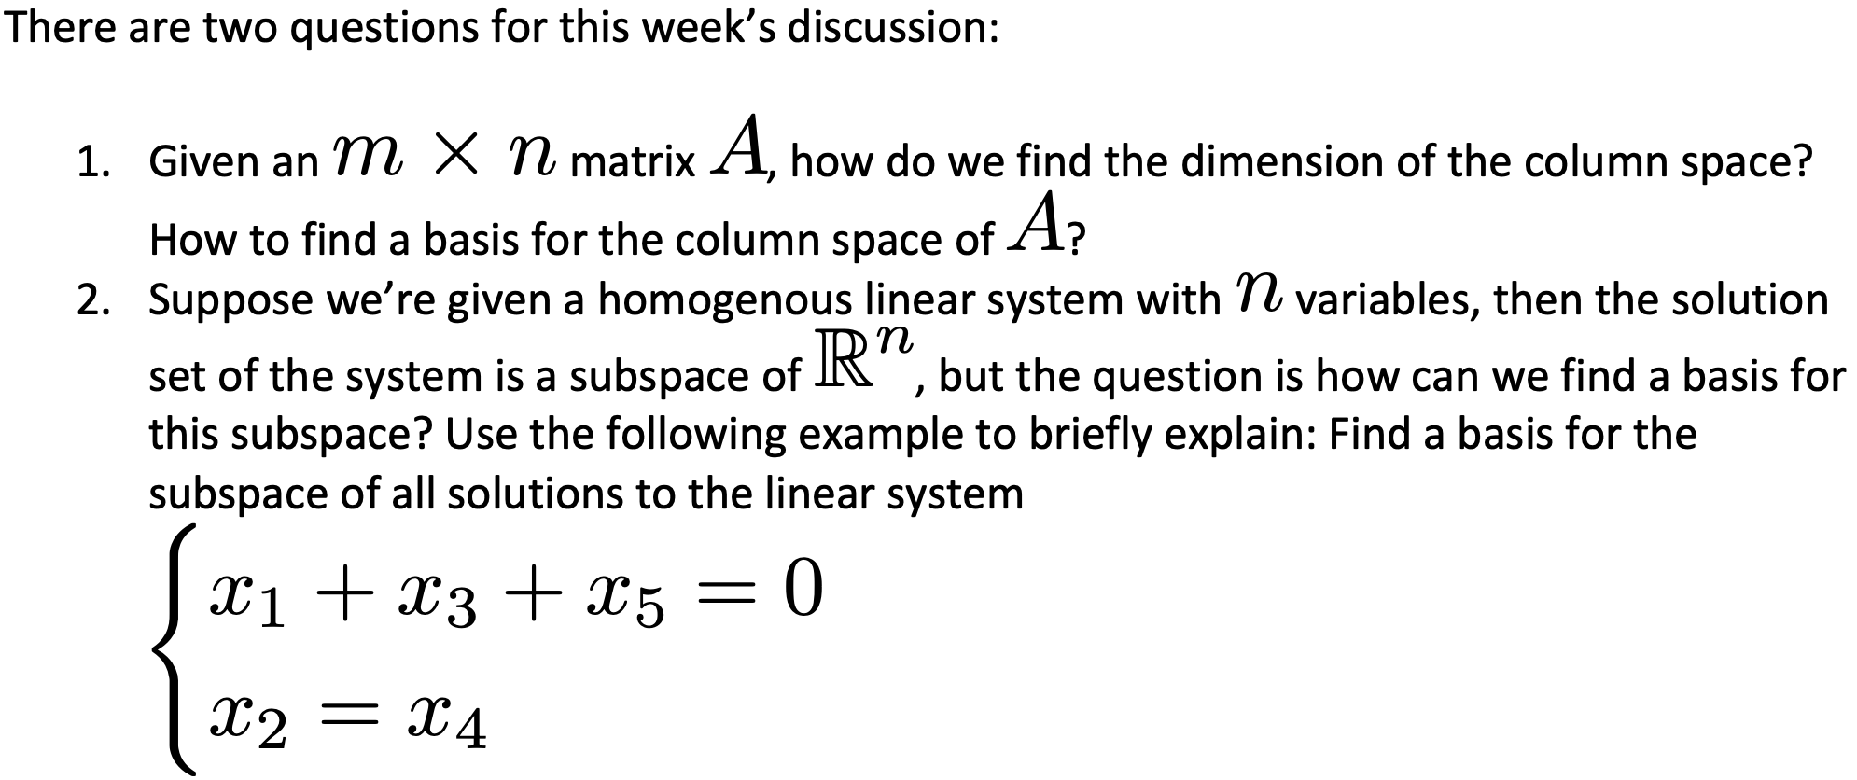
Jeremy Schreiber
RE: Discussion #9
COLLAPSE
窗体顶端
1. The easiest way to find a basis for A is to first find the reduced row echelon form of A. In this form, each column containing a pivot variable corresponds to the columns in A (the orignal matrix) that make up the basis for the column space. The dimension of this space is equal to the number of pivot variables in rref(A). The same result can be acheived by taking the transpose of A, A^T, and finding its reduced row echelon form. In this form, the vectors that form the basis of the column space are all of the non-zero row vectors. Note that the basis vectors produced by each method will likely not be the same, but the number of vectors in the basis will be.

2. The easiest way to find a basis for the null space of a linear system is to write the solution of the system in parametric vector form. In this form, the column vectors that multiply the free variables form the basis. In the example question we already have it in reduced row echelon form, which looks like this (brackets excluded):
1 0 1 0 1
0 1 0 1 0
Columns 1 and 2 contain the pivots, leaving columns 3, 4 and 5 representing the free variables. If we let x3 = s, x4 = t and x5 = u, we find that x2 = t and x1 = -s - u. Writing the solution in parametric vector form we get:
(x1, x2, x3, x4, x5) = s(-1, 0, 1, 0, 0) + t(0, 1, 0, 1, 0) + u(-1, 0, 0, 0, 1)
Thus producing the basis: { (-1, 0, 1, 0, 0), (0, 1, 0, 1, 0), (-1, 0, 0, 0, 1) }.

Reply to Jeremy Schreiber Quote Email Author
窗体底端
Hide 1 reply

10 days ago
Cheng Chang INSTRUCTOR MANAGER
RE: Discussion #9
COLLAPSE

12 days ago
Evan Kim
RE: Discussion #9
COLLAPSE
Hide 5 replies

12 days ago
Evan Kim
RE: Discussion #9
COLLAPSE
Hide 3 replies

12 days ago
Evan Kim
RE: Discussion #9
COLLAPSE
Hide 2 replies

12 days ago
Evan Kim
RE: Discussion #9
COLLAPSE
Hide 1 reply

10 days ago
Cheng Chang INSTRUCTOR MANAGER
RE: Discussion #9
COLLAPSE
窗体顶端
Hello Evan,
Your writing improved a lot.
Reply to Cheng Chang Quote Email Author
窗体底端

10 days ago
Cheng Chang INSTRUCTOR MANAGER
RE: Discussion #9
COLLAPSE
窗体顶端
Very good writing!!
Reply to Cheng Chang Quote Email Author
窗体底端

11 days ago
Sarah Mitchell
RE: Discussion #9
COLLAPSE
窗体顶端
1.
A is a m×n matrix.
Find A transpose .Then convert it into row reduced form.
Definition: An m×n matrix R is called row reduced if
(a)the first non zero entry in each non zero row of R is equal to 1;
(b)each column of R which contain the leading entry of some row has all its other entries 0.
In the row reduced form the number of non zero rows is the dimension of the column space of the given matrix A.These non zero rows form a basis of the column space of the given matrix A.
2. Please See Attached
duscussion #9, 2.pdf (475.163 KB)
Reply to Sarah Mitchell Quote Email Author
窗体底端
Hide 1 reply

10 days ago
Cheng Chang INSTRUCTOR MANAGER
RE: Discussion #9
COLLAPSE
窗体顶端
good.
Reply to Cheng Chang Quote Email Author
窗体底端

1 hour ago
Armani Willis
RE: Discussion #9
COLLAPSE
窗体顶端
We may find the dimension of the column space by:
1. Augment the matrix with a type 1 comparator
2. solve the matrix.
3. Eliminate the all zero functions of the solved matrix (ignore arg basis),
4. The amount of 0s rows in the solved matrix is the number of first columns in the basis,
5. That is also the dimension of the col space.
for #2, we can produce the matrix 1 n 1 n 1 |0+m,
or we can say: [1 0 1 0 1]+n[0 1 0 1 0]=m.
There is no way to combine these unless n=1 or if n=0.
窗体底端

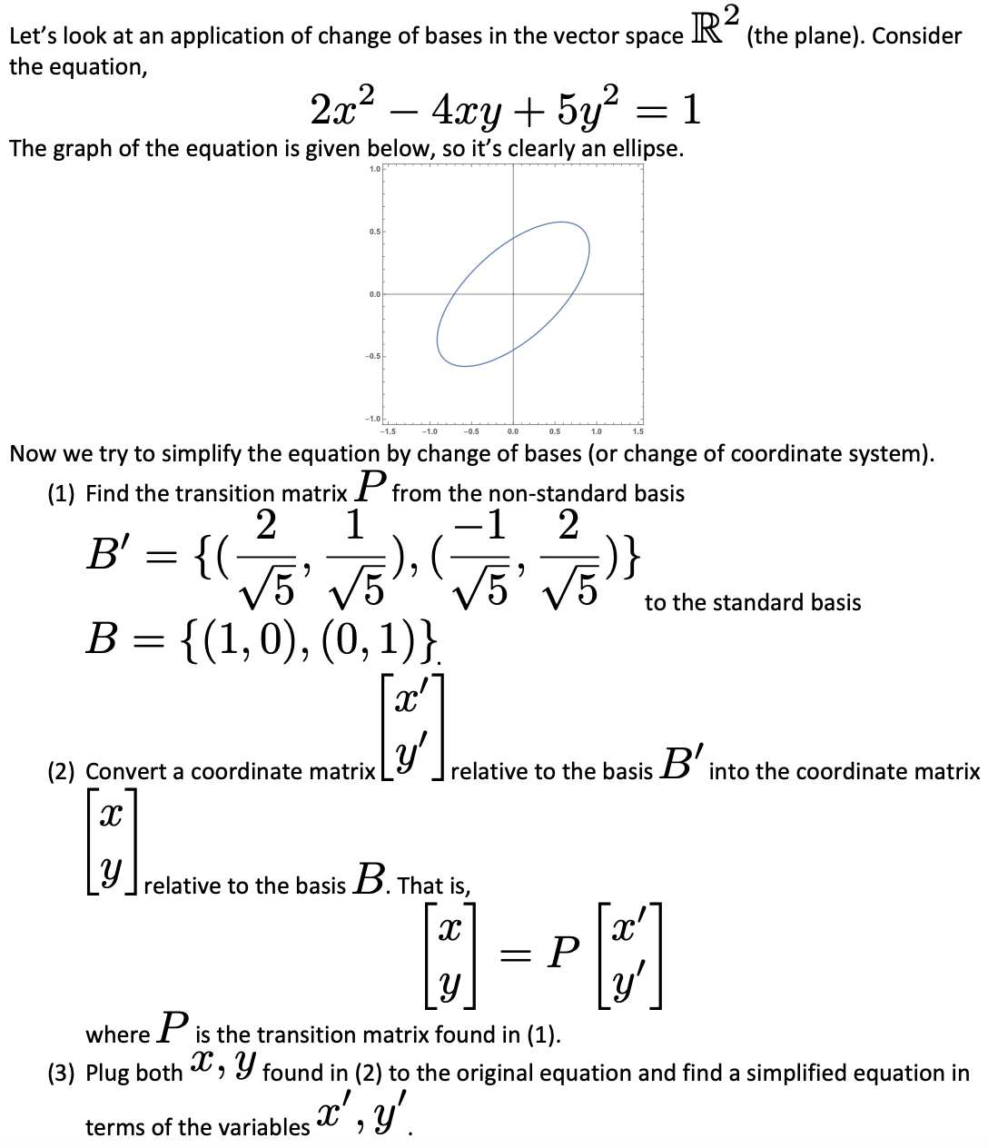
5 days ago
Evan Kim
RE: Discussion #10
COLLAPSE
窗体顶端
Discussion #10.pdf
Reply to Evan Kim Quote Email Author
窗体底端
Hide 1 reply

1 day ago
Cheng Chang INSTRUCTOR MANAGER
RE: Discussion #10
COLLAPSE
窗体顶端
I'm impressed by your LaTeX printing. The answer is almost correct, except the very end, the simplified equation is not correct.
Reply to Cheng Chang Quote Email Author
窗体底端

4 days ago
Sarah Mitchell
RE: Discussion #10
COLLAPSE
窗体顶端
Reply to Sarah Mitchell Quote Email Author
窗体底端
Hide 2 replies

1 day ago
Cheng Chang INSTRUCTOR MANAGER
RE: Discussion #10
COLLAPSE
窗体顶端
Perfect answer! Good work Sarah!
Reply to Cheng Chang Quote Email Author
窗体底端
Hide 1 reply

34 minutes ago
Armani Willis
RE: Discussion #10
COLLAPSE
窗体顶端
No, something's wrong. didn't use pemdas.
Reply to Armani Willis Quote
窗体底端

35 minutes ago
Armani Willis
RE: Discussion #10
COLLAPSE
窗体顶端
B'*rad5=02 -1 |-, x| 2x'-y'
01 02, y| x'+2y'
thus, 10(2x'-y')(2x'-y')-20(2x'-y')(x'+2y')+25(x'+2y')(x'+2y')=
5(4x'x'-4x'y'+2y'y'-8x'x'-16x'y'-8y'y'+5x'x'+20y'y')=
5(x'x'-20x'y'+14y'y').
窗体底端

Week 11.

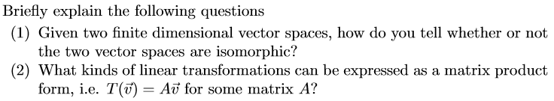

Isomorphism means similar to or relating to.
if I say 1 0 0 1
0 1 0 1
0 0 1 ﻿1﻿﻿﻿﻿﻿﻿﻿﻿﻿﻿﻿﻿﻿﻿﻿﻿﻿﻿﻿﻿﻿﻿﻿﻿﻿﻿, then ﻿﻿mxn=3x3=P3=I3, etc. these are all similar ways to represent this graph.
A is the standard matrix of T, where T{c}*[x]t=A(x), thus there must be an x corresponding to every T and every A since T is dependent upon A.

20 days ago
Armani Willis
RE: Discussion #11
COLLAPSE
窗体顶端
Isomorphism means similar to or relating to.
if I say 1 0 0 1
0 1 0 1
0 0 1 1, then mxn=3x3=P3=I3, etc. these are all similar ways to represent this graph.
A is the standard matrix of T, where T{c}*[x]t=A(x), thus there must be an x corresponding to every T and every A since T is dependent upon A.
Reply to Armani Willis Quote
窗体底端
Hide 4 replies

15 days ago
Armani Willis
RE: Discussion #11
COLLAPSE
窗体顶端
very good, armani.
concise, expressed in only 3 lines.
you know, since this is a math class, not an english class.
and that means when i ask a math question, i should expect a math answer.
Reply to Armani Willis Quote
窗体底端
Hide 3 replies

15 days ago
Jeremy Schreiber
RE: Discussion #11
COLLAPSE
窗体顶端
It's a shame that you didn't expect a correct answer.
Your example matrix for (1) isn't 3x3 it's 3x4, which isn't be the matrix between two isomorphic vector spaces because it doesn't have an inverse (it isn't square) and the requirement for the linear transformation between isomorphic spaces is that it's invertible (it must be an isomorphism). Hence, the dimensions of the domain and co-domain must be the same. In your example the dimension of the domain is 4 and co-domain is 3. So your answer is incorrect.
Your answer for (2) is unintelligible as written (maybe those English classes are useful after all)

Reply to Jeremy Schreiber Quote Email Author
窗体底端
Hide 2 replies

10 days ago
Armani Willis
RE: Discussion #11
COLLAPSE
窗体顶端
Jeremy, you proved only that you are unfamiliar with my style of writing.
Please reserve your answer responses to submissions that were not made by you yourself for the teacher,
since you are not the one teaching the class.
Reply to Armani Willis Quote
窗体底端
Hide 1 reply

10 days ago
Armani Willis
RE: Discussion #11
COLLAPSE
窗体顶端
https://www.youtube.com/watch?v=IWTMOYJe36A
Reply to Armani Willis Quote
窗体底端

18 days ago
Jeremy Schreiber
RE: Discussion #11
COLLAPSE
窗体顶端
1. According to the Theorem 6.9: Two finite-dimensional vector spaces V and W are isomorphic if and only if they are of the same dimension. In this case a bijective linear transformation (referred to as an isomorphism) exists between the two vector spaces.
2. A linear transormation between any two finite dimensional vector spaces can be expressed in matrix product form. For such a linear transformation, T, you can use the standard basis of the domain, S = {s1, s2, ..., sn}, to evaluate T(si) for i = 1 to n. Given that each vector, v, in the domain can be represented by the linear combination:
v = c1s1 + c2s2 + ... + cnsn
The value of T(v) can be expressed as:
T(v) = T(c1s1 + c2s2 + ... + cnsn) = T(c1s1) + T(c2s2) + ... + T(cnsn) = c1T(s1) + c2T(s2) + ... cnT(sn)
The last expression can be re-written as T(v) = Av, where A is the matrix constructed using each T(si) as its columns and v is the column vector of the coefficients.

Reply to Jeremy Schreiber Quote Email Author
窗体底端
Hide 1 reply

16 days ago
Cheng Chang INSTRUCTOR MANAGER
RE: Discussion #11
COLLAPSE
窗体顶端
Excellent writing!
Reply to Cheng Chang Quote Email Author
窗体底端

17 days ago
Evan Kim
RE: Discussion #11
COLLAPSE
窗体顶端
1) Two vector spaces are isomorphic when they are both one to one and onto. If a linear transformation is onto, then the rank of T is equal to the dimension of W in T: V-->W. If a linear transformation is one-to one in T: V --> W, T is one-to-one IFF ker(T) = {0}
2) When the function T meets the following criteria: (1) T(u+v) = T(u) + T(v) and (2) T(cu) = cT(u)
Reply to Evan Kim Quote Email Author
窗体底端
Hide 1 reply

16 days ago
Cheng Chang INSTRUCTOR MANAGER
RE: Discussion #11
COLLAPSE
窗体顶端
The first one is correct. For the second, you gave the definition of a linear transformation, but I'm asking when can you express an linear transformation by a matrix.
Reply to Cheng Chang Quote Email Author
窗体底端

17 days ago
Sarah Mitchell
RE: Discussion #11
COLLAPSE
窗体顶端
Please see attached.

Sarah M.
Discussion 11.pdf (487.753 KB)
Reply to Sarah Mitchell Quote Email Author
窗体底端
Hide 2 replies

17 days ago
Jeremy Schreiber
RE: Discussion #11
COLLAPSE
窗体顶端
Very well put.
Reply to Jeremy Schreiber Quote Email Author
窗体底端

16 days ago
Cheng Chang INSTRUCTOR MANAGER
RE: Discussion #11
COLLAPSE
窗体顶端
The proof for (1) is excellent, actually, I didn't expect that.
Reply to Cheng Chang Quote Email Author
15 days ago
Armani Willis
RE: Discussion #12
COLLAPSE
窗体顶端
The degree of the characteristic polynomial (yI-A) is n, and it only works in an nxn matrix.
This means that there are only up to n # of eigenvalues.
for the function (y-ci)^kj, although the multiplicity of k may repeat, the sum of j is always n,
and the sum of i cannot exceed n.
can we have more questions?
Reply to Armani Willis Quote
窗体底端
Hide 1 reply

10 days ago
Armani Willis
RE: Discussion #12
COLLAPSE
窗体顶端
Hey, everybody, I finally figured out how to do A^B.
Its really super simple. Now we can do SSA^udxdx.
Isnt that great?
Reply to Armani Willis Quote
窗体底端

13 days ago
Jeremy Schreiber
RE: Discussion #12
COLLAPSE
窗体顶端
1. The degree of the characteristic polynomial is n
2. There are potentially up to n eigenvalues
3. For A to be diagonalizable there needs to be n linearly independent eigenvectors in order to create the n x n matrix P. If all of the values of k are equal to 1, then there are n distinct values of c and hence n distinct eigenvalues. This can be considered the trivial case. In the cases where one (or more) of the k parameters is greater than 1, there are fewer than n c parameters and thus fewer than n eigenvalues. In order for A to remain diagonalizable (to produce the n linearly independent eigenvectors needed for P) the dimension of the eigenspace related to each c should equal the value of the corresponding k. In this case, the basis for each eigenspace will contain k vectors and since the sum of all of the k parameters is n, there will be n vectors (the bases for each eigenspace) that can be used for P.
Reply to Jeremy Schreiber Quote Email Author
窗体底端
Hide 1 reply

4 days ago
Cheng Chang INSTRUCTOR MANAGER
RE: Discussion #12
COLLAPSE
窗体顶端
Great job Jeremy. This is a perfect answer.
Reply to Cheng Chang Quote Email Author
窗体底端

10 days ago
Evan Kim
RE: Discussion #12
COLLAPSE
窗体顶端
Reply to Evan Kim Quote Email Author
窗体底端
Hide 1 reply

4 days ago
Cheng Chang INSTRUCTOR MANAGER
RE: Discussion #12
COLLAPSE
窗体顶端
(1) and (2) are correct. For (3), there is a possibility that the dimension of an eigenspace is not equal to the multiplicity of the eigenvalue corresponding to the eigenspace, in this case, the matrix is not diagonalizable.
Reply to Cheng Chang Quote Email Author
窗体底端

10 days ago
Sarah Mitchell
RE: Discussion #12
COLLAPSE
窗体顶端
1. If A is an n x n matrix, then characteristic polynomial is |I - A |, which has degree n.
2. There are n eigenvalues because the eigenvalues are the root of the characteristic polynomial of n degree.
3. If the characteristic polynomial is factored as |I - A|= (- c₁)^{k}₁ (-c₂)^{k}₂ ...(- c_{i})^{k}_{i}
Then c₁, c_{2, ...} c_{i} are eigenvalues of k1, k2, ..., ki multiplicity respectively.
Then A is diagonalizable if the number of linearly independent eigenvectors of c1, c2, ..., ci is k1, k2, ..., ki respectively.
That is if the algebraic multiplicity is equal to geometric multiplicity for each eigenvalue.
Reply to Sarah Mitchell Quote Email Author
窗体底端
Hide 1 reply

4 days ago
Cheng Chang INSTRUCTOR MANAGER
RE: Discussion #12
COLLAPSE
窗体顶端
Very good answer.
Reply to Cheng Chang Quote Email Author
窗体底端

8 days ago
Armani Willis
RE: Discussion #12
COLLAPSE
窗体顶端
I think I solved the question we had in class, of whether A*A has the same eigenvectors...
for (y-ci)^kj, i and j should be the same for both square matrixes, however, If A=D, then
1 0 0 01 1 0 0 1 y-1=y-1 thus (y-1)(y+2)(y-3)/=(y-1)(y-4)(y-9)
0 1 0 -2 0 4 0 1 y+2/=y-4 Only I*I should have the same eigenvectors.
0 0 1 03 0 0 9 1 y-3/=y-9 Is this right?
Reply to Armani Willis Quote
窗体底端
Hide 1 reply

8 days ago
Evan Kim
RE: Discussion #12
COLLAPSE
窗体顶端
Your writing is incomprehensible.
- Does A*A have the same eigenvectors as....what? I can guess that you might be referring to Problem 12 (2) from the Final Practice Part 2.
- In A = D, you never said what D is
- Are all your numbers supposed to be a matrix, a vector, What is the relationship between them?
窗体底端
All of the definitions are clearly there.
D stands for any diagonal matrix, as shown.
A*A is being compared to A, as shown.
the answer for your question 3 was also shown.

